ISOPENTANE FREEZING PROTOCOL FOR MUSCLE BIOPSY

Equipment and Materials

- Polystyrene container for liquid nitrogen
- Floating platform (polystyrene) with punched hole for plastic cold-resistant container (see diagram below).
- Adhesive gum (or tissue teck).
- Cork supports
- Isopentane
- Cryotubes (2 ml) for conditioning tissues.

Procedure

1. Prepare the polystyrene container. Fill to three-quarters mark.

Nitrogen
¾ mark

2. Take the floating platform with the punched hole, and put the "isopentane" container on it. Then pour the isopentane into the container up to the mark.

Isopentane container Punched floating platform

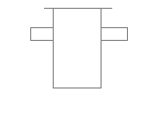

3. Carefully place the floating platform with the isopentane on top of the nitrogen (it will float), allow the isopentane to cool until white crystals appear at the bottom of the container.

Nitrogen 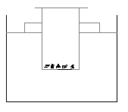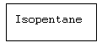

4. Place a drop of adhesive gum or "Tissue-Teck" on the cork support, place the tissue on the gum, and drop the whole thing into the cooled isopentane. Leave for 2 minutes.

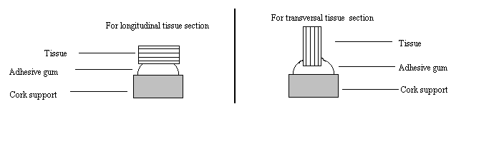

5. Label the cryotubes

6. Cool the cryotubes in liquid nitrogen (30 seconds) BEFORE placing the tissue-cork-gum constructions in them.

7. Store the cryotubes at –80°C or in a liquid nitrogen container.

